Autumn 2000

Class II Information Technology Engineer Examination (Morning)

Questions must be answered in accordance with the following:
Question Nos. | Q1 to Q80
Question Selection | All questions are compulsory
Examination Time | 9:30-12:00 150 minutes
Instructions:
1. Use an HB pencil.
If you need to change an answer, erase your previous answer completely and neatly. Wipe away any eraser debris.
2. Mark your answers in accordance with the instructions below. Your answers will not be graded if you fail to comply with the instructions. Do not mark or write on the answer sheet outside of the prescribed places.

(1) Examinee Number
Write your examinee number in the space provided, and mark the appropriate space below each digit.

(2) Date of Birth
Write your date of birth (in numbers) exactly as it is printed on your examination admission card, and mark the appropriate space below each digit.
How to Mark Your Answers

(3) Answers
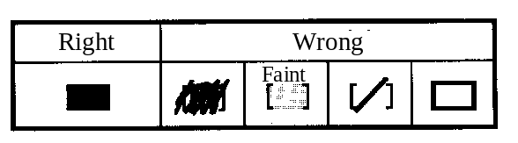
Select one answer (A through D) for each question.
Mark your answer as shown in the following sample
question.
[Sample Question] In which month is the Fall Information Technology Engineer Examination conducted?

a) 8 | b) 9 | c) 10 | d) 11

Since the correct answer is "C" (10), mark your answer sheet as follows:

[Sample Reply] a) b) c) d)
Do not open the exam booklet until instructed to do so.
Inquiries about the exam questions will not be answered)

Q1. What is the decimal value of the Binary Coded Decimal (BCD) value 100100010101?

a) –277 b) 915 c) 2325 d) 4425
Ans: B. Đây là sử dụng mã nhị phân để biểu diễn hệ thập phân 1001 0001 0101 = 9 1 5 (sử dụng 4 bit cho 1 chữ số)

Q2. Which of the following is equal to the hexadecimal value 2A)4C?

a) 2⁵+2³+2¹+2^{–2}+2^{–5}+2^{–6} b) 2⁵+2³+2¹+2^{–1}+2^{–4}+2^{–5}
c) 2⁶+2⁴+2²+2^{–2}+2^{–5}+2^{–6} d) 2⁶+2⁴+2²+2^{–1}+2^{–4}+2^{–5}
Ans: Đáp án A. 2A.4C = 0010 1010 . 0100 1100, các chữ số 1 tương ứng với các hệ số 5, 3, 1, -2, -5, -6.

Q3. What is the fewest number of binary digits that are needed in order to represent all possible natural numbers which have five digits when represented as octal numbers?

a) 5 b) 10 c) 15 d) 20

Ans: Đáp án C. Một chữ số cơ số 8 được biểu diễn bằng 3 chữ số cơ số 2.

Q4. According to the IEEE754 (1985) standard, the 32-bit floating point number format is as follows:

S | E（8-bit） | M（23-bit）
S: Sign, 1 bit
E: Exponent part, 8 bits
M: Mantissa part, 23 bits

Which of the following hexadecimal values expresses the mask bits used to extract the index? Here, “mask bits” refers to a bit pattern that is ANDed with the 32-bit floating-point value in order to extract the necessary information.

a) 0FF00000 b) 7F800000 c) FF000000 d) FF800000

Ans: Đáp án B. Để lấy phần E ta phải AND các bit của E với 1, và các bit khác thành 0. -> 7F800000 = 0111 1111 1000 0000 0000 0000 0000 0000

Q5. Assume that “a” is the value produced by a 2-bit logical shift to the left executed on the contents of the 16-bit fixed-point register shown below, and “b” is the value produced by a 3-bit logical shift to the right executed on the contents of the 16-bit fixed-point register shown below. What multiple of “b” is the value of “a”? Assume that empty bits produced by the shift take a value of “0.”

0 | 0 | 0 | 0 | 0 | 0 | 0 | 1 | 0 | 1 | 0 | 0 | 0 | 0 | 0 | 0

a) 6 b) 12 c) 24 d) 32

Ans: Đáp án 32. Gọi giá trị của số này là x . Ta có a = 4 * x, b = x / 8 => a / b = 32.

Q6. Which of the following is a hexadecimal representation of the ASCII codes for the character string “STAR”? Assume that bit 8 of each character code is an even parity bit.

[Partial ASCII code table]
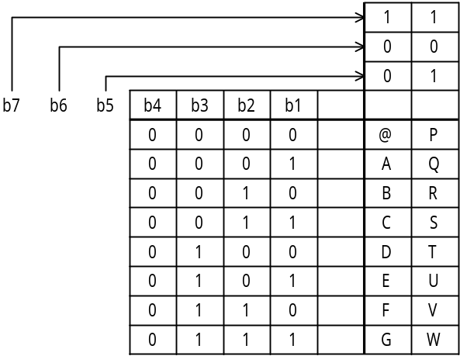

a) 1DA50C95 b) 53D441D2 c) 659541A5 d) D354C152
Ans: Đáp án B. Ta thấy với ký tự S sẽ là 01010011 -> 53

Q7. Which of the following floating-point operations causes a cancellation? Assume that the mantissa has three valid digits, and that the operation is performed on six digits.

a) 0.123×10²+0.124×10^{–2} b) 0.234×10^{5―}0.221×10²
c) 0.556×10⁶+0.552×10⁴ d) 0.556×10^{7―}0.552×10⁷
Ans: Đáp án D Khi trừ 2 số gần bằng nhau thì có thể nhận được giá trị nằm ngoài khoảng có thể biểu diễn được, trường hợp này gọi là triệt tiêu (cancellation)

Q8. Two stack operations are defined as follows:
PUSH n : Pushes data (the integer n) onto the stack.
POP : Pops data out of the stack.
What is the result produced by performing the following series of stack operations on an empty stack?

PUSH 1 → PUSH 5 → POP → PUSH 7 → PUSH 6 → PUSH 4 → POP →

POP → PUSH 3

a) |  | b) |  | c) |  | d)
 | 1 |  | 3 |  | 3 |  | 6
 | 7 |  | 4 |  | 7 |  | 4
 | 3 |  | 6 |  | 1 |  | 3
Ans: Đáp án C. (1) -> (1,5) -> (1) -> (1,7) -> (1,7,6) -> (1,7,6,4) -> (1,7,6) -> (1,7) -> (1,7,3)

Q9. “NOR” (negative logical sum) is one type of dyadic logical operation. Which of the four choices below is the correct result to be inserted in the line “x NOR y”?

x | 0 | 0 | 1 | 1
y | 0 | 1 | 0 | 1
x NOR y

a) | 0 | 0 | 0 | 1
b) | 0 | 1 | 1 | 0
c) | 1 | 0 | 0 | 0
d) | 1 | 1 | 1 | 0
Ans: Đáp án C. x NOR y = NOT (x OR y)

Q10. The function eq (X, Y) returns a value of “1” if the parameters “X” and “Y” are equal and a value of “0” if they are not. What are the necessary conditions for “1” to be returned when eq (eq (A, B), eq (B, C)) is called?

a) A = B and B = C
b) A = B or B = C
c) (A = B and B = C) or A = C
d) (A = B and B = C) or (A ≠ B and B ≠ C)
Ans: Đáp án D. eq(eq(A,B),eq(B,C)) = 1 khi eq(A,B) và eq(B,C) cho cùng giá trị hay đồng thời A=B và B = C hoặc A khác B và B khác C.
Q11. In the following logical circuit, when S = 1, R = 1, X = 0, and Y = 1, S is changed to “0” and then is changed back to “1.” What are the values of “X” and “Y” after this operation is performed? Here, 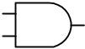 represents an AND (logical product) gate and  represents a NOT gate.

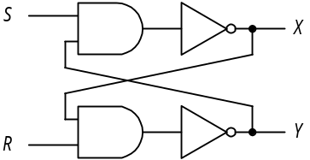

a) X = 0, Y = 0 b) X = 0, Y = 1 c) X = 1, Y = 0 d) X = 1, Y = 1
Ans: Đáp án B. X’ = NOT (S AND Y) = NOT ( 1 AND 1) = 0, Y’ = NOT (R AND X) = NOT (1 AND 0) = 1

Q12. Repeating the following procedure four times divides a 16-bit unsigned fixed-point binary number into hexadecimal digits and then stores each digit in a stack, starting from the lowest digit. Which combination of phrases for “a” and “b” is correct? Here, the notation “xxxx₁₆” represents the hexadecimal value “xxxx.”

[Procedure]
(1)  → x
(2) Shift n  .
(3) Push x onto the stack.

 | a | B
a) | n AND 000F₁₆ | four bits to the left
b) | n AND 000F₁₆ | four bits to the right
c) | n AND FFF0₁₆ | four bits to the left
d) | n AND FFF0₁₆ | four bits to the right

Ans: Đáp án B. n AND 000F sẽ cho ta giá trị của chữ số cuối cùng của n, và giá trị x đó được lưu vào stack. Sau đó, ta dịch chuyển các chữ số còn lại sang 1 vị trí bằng cách dịch chuyển 4 bit sang phải. (xyzt AND 000F -> 000t -> Stack-> xyzt shift right 4 chu so -> 0xyz).
Q13. The following procedure demonstrates a shell sort. When the data sequence “7, 2, 8, 3, 1, 9, 4, 5, 6” is sorted by repeating steps (1) through (4) below, how many times does step (3) have to be repeated? For the purposes of this question, the decimal fraction of any value enclosed in brackets below is truncated.

[Procedure]
(1) [Number of data elements÷3] → H.
(2) Break up the data sequence into sub- sequence, each of which is obtained by picking from the original sequence those elements which are H elements apart, and then sort elements in each sub- sequence by the insertion sort.
(3) [H÷3] → H
(4) If H is “0,” sorting is complete. If H is not “0,” return to step (2).

a) 2 b) 3 c) 4 d) 5
Ans: Đáp án A. (1) H = 9 /3 = 3 (2) (3) H /3 = 1 (4) (2) (3) H /3 = 0 -> end

Q14. Assume that there is a table in which “n” unique data elements have been sorted in the ascending order. This table is then divided into “m” blocks, and the block that contains the target data is found by conducting a linear search of the last data element in each of the blocks. Next, the target data is found by conducting a linear search within the target block. What is the average number of searches that must be performed? Assume that m < n, and that the target data definitely exists in the table.

a) b) c) m ⁺ d) ⁺
Ans: Đáp án D. Ta nhận thấy số bước tìm kiếm trung bình tới target block là m/2. Số bước tìm kiếm trung bình trong một target block là n/2m (Mỗi target block chứa khoảng n/m phần tử)

Q15. An operation compares the values of adjacent elements in a sequence and then switches their positions if the smaller value is on the right. “One pass” is defined as the repeated execution of this operation for all elements in the data sequence, starting from the left and proceeding to the right. Given the data sequence shown below, what is the resulting sequence that is produced by two passes of this operation?

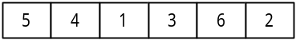

a) 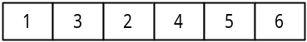 b) 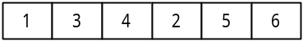

c) 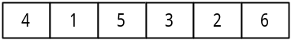 d) 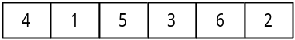
Ans: Đáp án B. Sau 2 lần pass, dãy được sắp xếp như sau:
5 4 1 3 6 2
-> (4 1 3 5 2 6) -> (1 3 4 2 5 6)

Q16. Which of the following statements applies to the clock that is used to control a processor?

a) If the processor has the same architecture, a higher clock frequency means that more instructions can be executed in a given unit of time.
b) The reciprocal of the clock frequency is equivalent to the number of instructions that can be executed within one second.
c) If no programs are running, the clock stops.
d) The series of processes from fetching an instruction to executing it can be performed within one clock cycle.
Ans: Đáp án A. Với một tần số đồng hồ cao, có nghĩa là việc thực hiện nhiều câu lệnh hơn trong một đơn vị thời gian, do thực hiện các câu lệnh được đo bằng đơn vị xung nhịp đồng hồ. B sai do không phải số câu lệnh được thực hiện trong vòng 1 giây không phải tính theo nghịch đảo xung nhịp đồng hồ. C sai vì không có chương trình chạy thì đồng hồ vẫn chạy. D sai vì tất cả các lệnh đơn của bộ xử lý đều được tính theo đơn vị xung đồng hồ chứ không phải một số lệnh có thể thực hiện trong một xung đồng hồ.

Q17. Assume a personal computer with a 200MHz processor. If the average instruction requires five clockcycles for execution, how many microseconds is the average instruction execution time for this personal computer?

a) 0.005 b) 0.025 c) 5 d) 25
Ans: Đáp án D. 200MHz -> 200000 xung nhịp đồng hồ trong 1 giây. Mỗi lệnh sử dụng 5 xung đồng hồ -> số thời gian sử dụng cho một lệnh là 5/200000 (s) = 5/200 (ms) = 0.025 (ms) = 25 (microsecond)

Q18. Assuming a cache memory that has an access time that is 1/30 of the main memory access time, and a 95% hit rate, what multiple of the main storage unit access time is the effective memory access time?

a) 0.03 b) 0.08 c) 0.5 d) 0.95
Ans: Đáp án B. Gọi thời gian truy cập của main memory time là x -> thời gian truy cập của cache memory là x/30. Tỉ lệ truy cập bộ nhớ cache là 95% -> thời gian trung bình là 95% * x/30. Tỉ lệ truy cập bộ nhớ memory là 5% -> thời gian trung bình là 5% * x. Ta có thời gian truy cập trung bình là 0.95 * x / 30 + 0.05 * x ~ 0.08 * x

Q19. The instruction “LOAD GR, B, AD” loads into general-purpose register GR the data that is stored in main memory at the address that is generated by adding the contents of base register B to AD)
Assuming the initial state shown in the diagram below, what will be the value in general-purpose register GR after the following instruction is executed?

LOAD GR, 1, 200

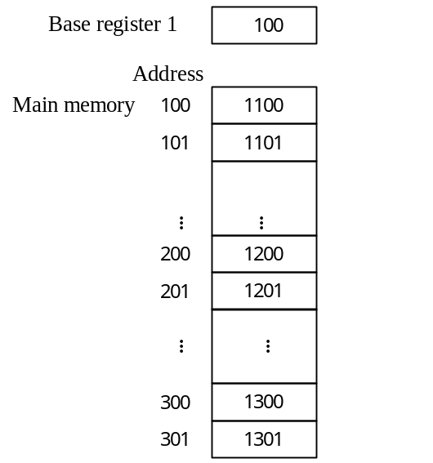

a) 1100 b) 1200 c) 1201 d) 1300
Ans: Đáp án D. Ta tính được địa chỉ lưu trữ dữ liệu để nạp vào GR là 100 + 200 = 300

Q20. Which of the following error control methods for memory is used in automatic error correction functions?

a) Horizontal parity check b) Checksum
c) Check digit d) Hamming code
Ans: Đáp án D. Chỉ có mã Hamming mới có thể sửa lỗi.

Q21. Which of the following statements concerning DVDs is true?

a) They can be read by a CD-ROM drive.
b) When using single-sided dual layer recording, they have a maximum storage capacity that is approximately four times that of a CD-ROM.
c) There are three types: read-only, recordable, and rewritable.
d) Data is recorded optically and magnetically.
Ans: Đáp án C. A sai vì không thể đọc bởi một CD-ROM drive. B sai vì nó có dung lượng gấp khoảng 16 lần một đĩa CD – ROM. D sai vì dữ liệu được lưu trên DVD không phải bằng từ

Q22. For a hard disk drive with the specifications shown in the table, what is the approximate average time (in milliseconds) needed to completely retrieve 512 bytes (one sector) of data?

Data length | 512 | bytes/sector
Average search time | 6 | ms
Average seek time | 9 | ms
Data transfer rate | 128 | k bytes/second

a) 10 b) 16 c) 19 d) 55
Ans: Đáp án C. Thời gian truyền dữ liệu = 512/ 128k ~ 4 ms. Thời gian trung bình để truyền là 6 + 9 + 4 = 19 ms.

Q23. A user wants to sequentially store 100,000 records (each consisting of 200 bytes) in a hard disk drive with the specifications shown in the table. How many cylinders are required if 10 records are recorded as one block? One block can span multiple sectors, but if the block length is not a multiple of 256, the excess portion of the last sector is left unused)

Number of tracks/cylinder | 19
Number of sectors/track | 40
Number of bytes/sector | 256

a) 103 b) 105 c) 106 d) 132
Ans: Đáp án D. Dung lượng cần ghi trên một block = 200 < 256. Do độ dài của block không phải là 256, nên số sector được dùng là 10 sector/1 block. Số lượng block trên 1 track là 40/10 = 4 block. Số lượng block trên 1 cylinder = 19 * 4 = 76 block. Cần phải chứa tổng cộng 100000 records = 10000 block -> Số cylinder cần để chứa 10000 block = 10000 / 76 = 131.xxx -> 132

Q24. Given a PC card with a data transfer rate of 27MB/second, approximately how many 640 × 480-dot images can be transferred in one second? Assume that 24 bits are used to express each dot of an image, 1MB is 1024KB, and 1KB is 1024 bytes.

a) 3 b) 20 c) 30 d) 92
Ans: Đáp án A. Số lượng các ảnh truyền trong 1 s = 27 MB / 640 * 480 * 24 = 3,84 -> 3 ảnh

Q25. Which of the following statements concerning the features of USB is true?

a) USB utilizes a high-speed transfer method that is suited for data transfers that must be conducted in real-time, such as audio and video data transfers. USB permits devices to be connected in daisy-chain fashion or in tree fashion, and permits connection even in the absence of a personal computer acting as host.
b) Peripheral devices are connected through a personal computer acting as host. USB supports multiple data transfer modes; generally, a printer or scanner uses full-speed mode, and a keyboard or mouse uses low-speed mode.
c) USB is a serial interface that was originally designed for connecting modems, but is now used for connecting peripheral devices to a personal computer.
d) USB is a parallel interface that connects hard disks, laser printers and other peripheral devices to small-scale computers, including personal computers.
Ans: Đáp án B. A sai vì đó là giải thích cho SCSI. D sai vì USB là một giao diện nối tiếp, đó là giải thích cho giao diện Centronic. C sai vì đó là nói về chuẩn RS-232C, được thiết kế dành riêng cho modem.

Q26. Which of the following is the best index of laser printer performance?

a) Number of dots per inch (2.54 cm) and number of pages that can be printed per minute
b) Number of dots (in the vertical and horizontal directions) used to print one character, and the number of characters that can be printed per second
c) The spacing between lines and the number of lines that can be printed per second
d) The types of characters that can be printed and the number of characters that can be printed per second
Ans: Đáp án A. Tốc độ của máy in là số điểm in tính trên 1 đơn vị inch và số trang tính trên đơn vị phút.

Q27. Which of the following could be the cause of a program interrupt?

a) An input/output operation was completed.
b) A hardware failure occurred.
c) An overflow occurred as the result of an operation in the program.
d) The program timed out.
Ans: Đáp án C. Một ngắt chương trình là một ngắt do bản thân chương trình thực hiện chứ không phải ngắt của các thiết bị khác. A, B là ngắt vào/ra, D là ngắt đồng hồ.

Q28. Which of the following statements concerning page-swapping in virtual memory management describes the LRU control method?

a) A reference flag and a change flag are added to each page for management purposes, and priority is given to swapping pages that have not been referenced or changed.
b) All pages in the main memory have the same probability of being selected for swapping.
c) The page which has not been referred to for the longest time is swapped.
d) The page which has resided for the longest time in the main memory is swapped.
Ans: Đáp án C. LRU có nghĩa là Least Reference Used có nghĩa là trang mà lâu không được dùng nhất sẽ bị swap ra.

Q29. Which of the following is used for mutual exclusion?

a) Contention b) Semaphores
c) Check points d) Hash
Ans: Đáp án B. Semaphore là thành phần dùng trong chức năng kiểm soát loại trừ.

Q30. What is the yardstick that is used to evaluate the ability of a system to process jobs within a given unit of time?

a) MIPS value b) Response time
c) Throughput d) Turnaround time
Ans: Đáp án C. Thông lượng là số công việc thực hiện của một hệ thống trong một đơn vị thời gian. A dùng đo hiệu năng của CPU. B là thời gian đáp ứng của hệ thống tính từ lúc gửi yêu cầu và bắt đầu trả lời. D là thời gian thực hiện tính từ lúc bắt đầu gửi yêu cầu và nhận kết quả trả về.

Q31. Which of the following explanations of how memory usage is calculated in order to estimate performance is correct?

a) Memory usage is calculated for each of the OS space and the user space on the basis of the total memory required and the amount of memory actually installed.
b) Memory usage is calculated on the basis of the weighted average number of dynamic steps and the amount of data processed by the system as a whole.
c) Memory usage is calculated for each processing model on the basis of the length of the messages that flow in all circuits and the volume of communications.
d) Memory usage is calculated for each processing model on the basis of the input/output record size and the number of accesses.
Ans: Đáp án B. A sai vì đó tỉ lệ đáp ứng của bộ nhớ. C là tỉ lệ sử dụng đường truyền. D là tỉ lệ sử dụng tài nguyên.

Q32. The following table lists the priority of three tasks and the amount of time that each task occupies the CPU and an I/O device when each task is executed independently. Assuming an OS that schedules tasks according to their priority, what is the total number of milliseconds that task C is in the executable state, starting from the point when all three tasks become executable until task C ends? Assume that the I/O for all tasks can be performed in parallel, and that OS overhead is negligible.

Task | Priority | Time occupied for individual task execution (unit: ms)
Task | Priority | CPU → I/O → CPU → I/O → CPU
A | High | 4 | 4 | 3 | 5 | 3
B | Medium | 2 | 6 | 3 | 6 | 2
C | Low | 2 | 5 | 3 | 4 | 1

a) 2 b) 5 c) 8 d) 11
Ans: Đáp án D. Ta sẽ tính như sau (E: execute, R: ready, W: waiting, I: Input/Output)
CPU :AAAABBCCAAA*BBBCAAACCBB**C
I/O (A) : AAAA AAAAA
I/O (B) : BBBBBB BBBBBB
I/O (C) : CCCCC CCCC
State A :E E E E I I I I E E E I I I I I E E E
State B :RRRREE I I I I I I RRR I I I I I I R R
State C :RRRRRREE I I I I IRRERRREE I I I I E

Q33. Upon analyzing the turnaround time for a given job, it was found that CPU time accounted for 2/3 of 1,350 seconds, and I/O accounted for the remainder. After taking into account an increase in the amount of data to be processed and improved performance, it is expected that one year later the CPU time will be 80% of what it was the year before. Due to the increase in the amount of data to be processed, it is also expected that the I/O time will be 120% of what it was the year before. What will the turnaround time for this job be after one year? Assume that idle time, overhead, etc., are negligible.

a) 1,095 b) 1,260 c) 1,500 d) 1,665
Ans: Đáp án B. Trước đây, thời gian xử lý CPU = 2/3 * 1350 = 900 s. Thời gian I/O = 450s. Sau một năm, thời gian CPU = 80% * 900 = 720 s. Thời gian I/O = 120% * 450 = 540s => Thời gian sau 1 năm = 720 + 540 = 1260s

Q34. Which of the following statements concerning the spooling function is true?

a) If the CPU becomes idle due to the execution of an I/O instruction while executing a given task, the spooling function allocates the CPU to another task.
b) The spooling function temporarily interrupts the program that is being executed and passes control to the control program.
c) The spooling function performs transfers between main memory and slow I/O devices through auxiliary memory, improving the overall throughput of the system.
d) The spooling function prepares a buffer pool that contains multiple buffers and shortens access times by increasing the probability that a given buffer in main memory will be accessed.
Ans: Đáp án C. Phương thức spooling được sử dụng để tăng tốc độ của hệ thống, do chênh lệch tốc độ giữa main memory với I/O. Các lệnh I/O sẽ được thực hiện song song với CPU bằng cách lưu trữ các lệnh I/O vào bộ nhớ phụ.

Q35. Which term describes the adjustment of addresses in a program to conform with the location in memory where a program is loaded when a program is loaded and then executed?

a) Virtual memory b) Optimization
c) Relocation d) Linking
Ans: Đáp án C. Virtual memory là thuật ngữ nơi lưu trữ tạm thời dữ liệu của bộ nhớ trên harddisk. Optimization là thuật ngữ dùng để chỉ tối ưu code. Linking là thuật ngữ dùng để liên kết các code với nhau trong quá trình compile.

Q36. In some circumstances, a program can be still running when it is called again by another program. Which of the following describes the called program if that program runs correctly in this situation?

a) Recursive b) Reusable
c) Reentrant d) Relocatable
Ans: Đáp án C. Reentrant cho phép chương trình khác gọi nó trong khi nó vẫn chạy.

Q37. Which of the following values is the closest to the availability of the entire system configuration shown in the diagram below? Assume that the availability of devices A and C is “0.9,” and the availability of devices B and D is “0.8.”

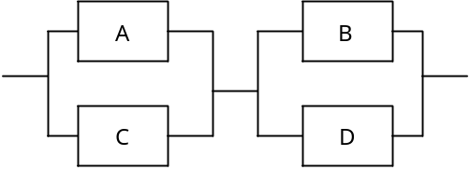

a) 0.72 b) 0.92 c) 0.93 d) 0.95
Ans: Đáp án D. Ta có thể xét hê thống hoạt động khi ( A + C) . (B + D) = 1 <=> A + C =1 và B + D = 1. Xác suất để A + C = 1 là: 1 – (A.C = 0) = 1 – 0.1 * 0.1 = 0.99. Xác suất để B + D = 1 là 1 – 0.2 * 0.2 = 0.96. Xác suất để hệ thống hoạt động = 0.99 * 0.96 = 0.95

Q38. In which of the following control methods does the terminal that is attempting to send a message first issue a send request and confirm that the other terminal is ready to receive, and then send the message?

a) Contention mode b) Token-bus method
c) Token-ring method d) Polling method
Ans: Đáp án D. A là phương thức giống với CSMA/CD, truyền không cần biết tới trạng thái kia có ready không. B, C là phương thức sử dụng thẻ bài, không cần biết thiết bị nhận có cần nhận được hay không.

Q39. Which device connects LANs to each other in the physical layer of the OSI basic reference model?

a) Gateway b) Bridge
c) Repeater d) Router
Ans: Đáp án C. Tầng vật lý là Repeater dùng để duy trì tín hiệu trong các đường truyền.

Q40. In the OSI basic reference model, which layer provides highly reliable, transparent, end-to-end data transfers between terminals by selecting an error detection function and recovery function in accordance with the transmission quality of the network being used?

a) Session layer b) Transport layer
c) Network layer d) Presentation layer
Ans: Đáp án B. Tầng để sử dụng các check lỗi và khôi phục dữ liệu là tầng transport. Tâng Presentation dùng để chuyển đổi dạng thức của dữ liệu thành dữ liệu cho tầng ứng dụng. Tầng Network cho phép điều khiển điều hướng dữ liệu.

Q41. A system transfers data between headquarters and the plant over a dedicated line. In this system, 256 bytes of data are used for one slip; data is sent in groups of ten slips, along with an 80-byte header. An average of 10,800 slips are generated per hour. Assuming the line speed is 9,600bps, what is the line usage rate (as a percentage)?

a) 8.25 b) 64 c) 66 d) 84
Ans: Đáp án C. Mỗi packet có 10 slip, có dung lượng là: 256 * 10 + 80 = 2640. Số packet gửi trong một giờ = 10800/10 = 1080 packet. Số packet gửi trong một phút = 18 packets -> dung lượng gửi trong 1 phút= 18 * 2640 * 8 = 380160 (bits). Tốc độ truyền trong 1 phút = 9600 * 60 = 576000 (bits). Tỉ lệ sử dụng đường truyền = 380160 / 576000 = 0.66 = 66%

Q42. Of the LAN standards defined in IEEE 802.3, which has a bus topology, has a transmission speed of 10Mbps, uses the baseband transmission method, and permits use of segments up to 185m long?

a) 100BASE-T b) 10BASE-T c) 10BASE2 d) 10BASE5
Ans: Đáp án C. Tốc độ truyền 10Mbps với độ dài 185m sẽ là 10BASE2 (10: 10Mps 2: 200m, T: twist, ko có: cáp đồng trục)

Q43. What is the means that is used in a WWW server to pass data that is input from a browser to an application program?
a) CGI b) HTTP c) MIME d) URL
Ans: Đáp án A. CGI dùng để trung chuyển dữ liệu từ WWW Server tới chương trình ứng dụng tương ứng. MIME là một định dạng mở rộng email cho các dữ liệu đặc biệt như hình ảnh, âm thanh.

Q44. Select the correct combination of terms for the following file organization methods:

 | a | b | C
Features | - Consists of a group of records called “members.”  - Suitable for program libraries.  - Has a directory area. | - Permits rapid access to a record that has a specific key value.  - The file occasionally needs to be re-organized.  - Records can be easily added or deleted. | - Permits rapid access to a record that has a specific key value.  - Generates synonyms.  - Uses media inefficiently.  - Records can be easily added or deleted.

 | a | b | c
a) | Partitioned organization | Indexed organization | Direct organization
b) | Partitioned organization | Direct organization | Sequential organization
c) | Indexed organization | Sequential organization | Partitioned organization
d) | Indexed organization | Direct organization | Partitioned organization
Ans: Đáp án A. a là kiểu tổ chức Partitioned organization bởi vì nó chia thành các vùng riêng biệt, nhóm các record thành các “member”. C là kiểu Direct do nó có các synonyms.

Q45. Which of the following explanations of schemas in a data base system is correct?

a) A schema is a virtual table from the viewpoint of the user, not an actual table.
b) A schema is a collection of data definitions, including data characteristics, formats, and relationships with other data.
c) “Schema” is a general term for data base operations, including data insertion, updating, deleting, and retrieval.
d) “Schema” is a general term for various restrictions and conditions that are needed in order to keep a data base in a perfect condition.
Ans: Đáp án B. Một lược đồ biểu diễn dữ liệu cũng như các mối quan hệ với các dữ liệu khác.
Q46. The diagram below depicts a directory structure that contains multiple directories named “A” and “B”. Select the final current directory after the current directory has been moved as follows: \A\B → .. → ..\B → .\A
Assume that the directory specification method described below is used)

[Directory specification method]
(1) When the specification begins with “\”, it is assumed that the root directory is specified to the left of the symbol.
(2) A directory is specified by a series of directory names in the path, starting from the highest directory and delimited by the “\” symbol, as follows: “directory-name\...\directory-name”
(3) The current directory is represented by “.”.
(4) The directory one level higher than the current directory is represented by “..”

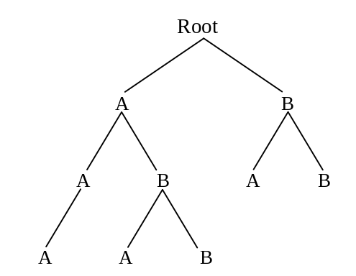

a) \A b) \A\A c) \A\B\A d) \B\A

Comment: The special character “\” is used in place of “/” in personal computers in Japan. This “\” should be replaced by “/” or the currency symbol corresponding to the same binary code.
Ans: Đáp án A. Chỉ có đường dẫn đó mới dẫn tới thư mục chứa cả 2 thư mục A và B còn các đường dẫn khác chỉ dẫn tới thư mục chứa 1 hoặc 0 có thư mục nào.

Q47. In a spreadsheet program, the following calculations are set up in each cell. If the value “2” is input in cell A1, what value appears in cell B3? Assume that when a value is input in a cell, the other cells are recalculated immediately.

 | A | B
1 |  | A1
2 | A1+1 | A2+B1
3 | A2+1 | A3+B2

a) 4 b) 5 c) 9 d) 10
Ans: Đáp án C. Ta có B1 = A1 = 2; A2 = A1 + 1 = 3; B2 = A2 + B1 = 3 + 2 = 5; A3 = A2 + 1 = 3 + 1 = 4; B3 = A3 + B2 = 5 + 4 = 9

Q48. Select the values to be produced when the contents of the following spreadsheet are written out in the CSV format. Assume that the line feed code “^{C}_{R}” is used as the delimiter between records, that the calculations in each cell are recalculated immediately, and that the calculated results are written out.

 | A | B | C
1 | 2 | 7 | A1+B2
2 | 6 | 4 | A2+B1
3 | A1+A2 | B1+B2 | C2+B3

a) 2 , 6 , 8 ^{C}_{R} 7 , 4 , 11 ^{C}_{R} 6 , 13 , 24 ^{C}_{R}
b) 2 , 6 , 8 ^{C}_{R} 7 , 4 , 11 ^{C}_{R} 9 , 10 , 19 ^{C}_{R}
c) 2 , 7 , 6 ^{C}_{R} 6 , 4 , 13 ^{C}_{R} 8 , 11 , 24 ^{C}_{R}
d) 2 , 7 , 9 ^{C}_{R} 6 , 4 , 10 ^{C}_{R} 8 , 11 , 19 ^{C}_{R}
Ans: Đáp án C. Dễ thấy ta có C1 = 6, C2 = 13, C3 = 24.

Q49. When an error occurs in data base operations, which of the following is the error recovery process that is performed in order to restore the data base to the state it was in before the start of the transaction?

a) Checkpoint b) Database dump
c) Roll back d) Roll forward
Ans: Đáp án C. Việc khôi phục dữ liệu trở lại trạng thái khi bắt đầu giao dịch là Roll back.

Q50. Which of the following explanations of log files in a DBMS is correct?

a) A log file is a file of updated data in memory that is written onto disk regularly in order to reduce the amount of time needed for database recovery process when the system goes down.
b) A log file is an identical copy of the data in a data base that is written into another data base on a different disk or at a different site in order to permit the system to run immediately even if a disk fails.
c) A log file is a copy of the contents of an individual disk in a data base that permits recovery of the data base in the event that a disk fails.
d) A log file is a record of updates made to a data base, and contains both the pre-update and post-update data from this file is used in data base recovery process.
Ans: Đáp án D. A sai do nó được dùng để sử dụng recovery chứ không phải để giảm thời gian cần thiết cho recovery. B sai vì nó không phải là một bản copy của database. C sai giống B. Log file chỉ đơn giản ghi lại các thao tác update database để sử dụng trong việc recovery database.

Q51. Select the normalized structure for the following order table:

Order No. | Order date | Customer | Product | Quantity | Unit price | Total amount
1 | 00/10/01 | A | S | 3 | 1,000 | 4,900
1 | 00/10/01 | A | T | 2 | 950 | 4,900
2 | 00/10/01 | B | S | 1 | 1,000 | 22,000
2 | 00/10/01 | B | U | 10 | 1,200 | 22,000
2 | 00/10/01 | B | V | 5 | 1,800 | 22,000
3 | 00/10/02 | B | T | 8 | 950 | 7,600
4 | 00/10/02 | C | U | 25 | 1,200 | 30,000
… | … | … | … | … | … | …

a) | Order No. | Order date | Customer | Total amount |  | Order No. | Product | Quantity |  | Product | Unit price

b) | Order No. | Order date | Customer | Total amount |  | Customer | Product | Quantity |  | Product | Unit price

c) | Order No. | Order date | Customer | Total amount |  | Order date | Product | Quantity |  | Product | Unit price

d) | Order No. | Order date | Customer | Total amount |  | Product | Quantity |  | Product | Unit price
Ans: Đáp án A. B sai do Customer không phải khóa ngoại lai để nối 2 bảng. C sai do Order date không phải khóa ngoại lai để nối 2 bảng. D sai do không có khóa nối giữa bảng 1 với bảng 2.

Q52. Which of the following is the best explanation of “reverse engineering” in regards to software?

a) Extracting the design specifications from installed software and using them for software development.
b) Designing software in the sequence of “output, processing, and input.”
c) Implementing software functions in hardware.
d) Selecting the development language and development tools on the basis of the content of the processing to be performed by the software.
Ans: Đáp án A. “Reverse engineering” là kĩ thuật từ software đã chạy để tạo ra bản thiết kế ứng dụng đó. Từ đó, modify nó để thiết kế ra software mới.

Q53. Which of the following statements concerning object-oriented programming is true?
a) An object is a template for a class.
b) “Encapsulation” refers to the creation of a library of classes.
c) A class always has at least one instance.
d) A class can inherit attributes and methods from its parent class.
Ans: Đáp án D. A sai do một đối tượng không phải là một template của một class mà nó là một instance của một class. B sai do “encapsulation” liên quan đến dữ liệu của đối tượng chứ không phải thư viện của lớp. C sai do một lớp có thể không có đối tượng nào (lớp ảo)

Q54. The diagram below depicts a program that consists of five functions, A through E. The table describes the interfaces between these functions. Each interface between two functions is numbered in the diagram, and these numbers correspond to the “No.” column in the table. In addition, functions A, D, and E all reference a special data area. What type of module connection relationship exists between functions A and E?

4
4
3
2
1
Special
data area
B
D
C
E
A
Table Interfaces between Functions
No. | Parameters | Return value
1 | Contents of data items | Contents of data items
2 | Contents of data items | Contents of data items
3 | Function code | None
4 | None | List

Fig. Program Configuration

a) Common connection b) Data connection
c) Content connection d) None (indirect connection)
Ans: ?????

Q55. In a given system, a value is calculated from the input data in accordance with fixed rules. The input data is checked by determining a check character on the basis of this calculated value, and then adding that check character to the end of the data)
When the following rules are used, which is the correct check character that is added to the four-digit numeric data “2131”?

[Rules]
(1) The following coefficients are assigned to each digit of the input data: 4, 3, 2, 1.
(2) The value digit is multiplied by the assigned coefficient of each and the products are summed over the digits.
(3) The value that was derived in (2) is divided by “11” in order to derive the remainder.
(4) The remainder that was derived in (3) becomes the check character. If the remainder is “10,” “X” is the check character.

a) 1 b) 3 c) 5 d) 7
Ans:Đáp án D. Ta có 2 * 4 + 1 * 3 + 3 * 2 + 1 * 1 = 18 -> 18 mod 11 = 7.

Q56. Which of the following statements concerning the control structure of a program is true?

a) “A loop with the termination condition at the bottom” evaluates the end condition at the start of the loop process.
b) “A two-way branch” selects whether to return to the previous process or to proceed to the next process.
c) “A multi-way branch” starts multiple processes in parallel.
d) “A loop with the termination condition at the top” sometimes results in the loop process not being performed at all.
Ans: Đáp án D. A sai vì biểu thức điều kiện nằm ở cuối vòng lặp. B sai vì không có việc quay trở lại process trước. C sai vì không có process song song.

Q57. One item of a record in a sales file is a process category in, and the process to be performed depends on this process category. The ratio of appearances of each processing class is already known for all sales data. Which of the following statements concerning the comparison counts for determining the process category is true?

a) The overall number of comparisons is reduced by using the value of the category with an intermediate ratio of appearance first.
b) The overall number of comparisons is reduced by using the value of the category with the highest ratio of appearance first.
c) The overall number of comparisons is reduced by using the value of the category with the lowest ratio of appearance first.
d) The overall number of comparisons does not change regardless of the order of evaluation.
Ans: ????

Q58. Which is the correct flowchart for using a sentinel to find x in the data stored in an array A[1] to A[n]?

a) b)
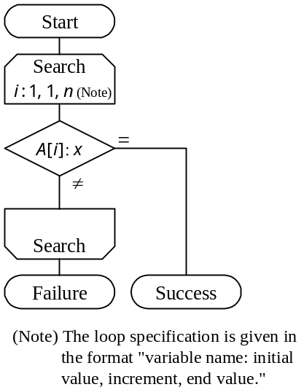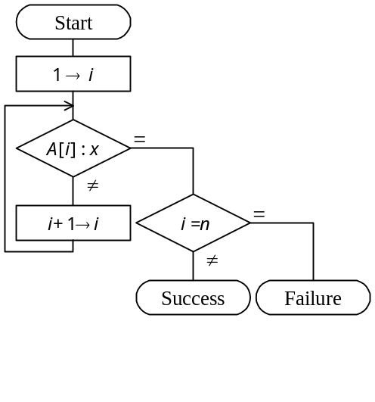

c) d)
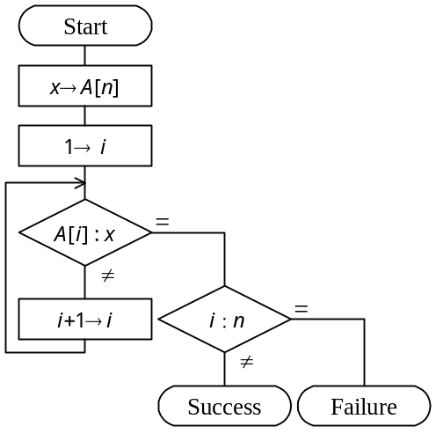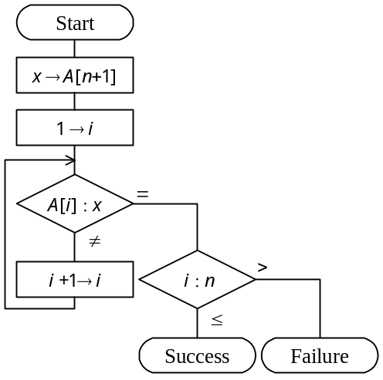
Ans: Đáp án D. Thuật toán tìm kiếm sử dụng lính canh bằng cách thêm vào một phần tử vào cuối có giá trị bằng phần tử tìm kiếm để khi chạy vòng lặp thì chắc chắn vòng lặp sẽ bị chặn tại phần tử đó.
Q59. The following flowchart describes a process for converting a decimal number j (0 < j < 100) to a binary number. The binary number is stored in elements 1 through 8 of the array BIN, starting from the least significant digit. What processing should occur in the spaces labeled "a" and "b" in the flowchart? Here, "j div 2" returns the integer portion of the quotient of j divided by 2, and "j mod 2" returns the remainder of j divided by 2.

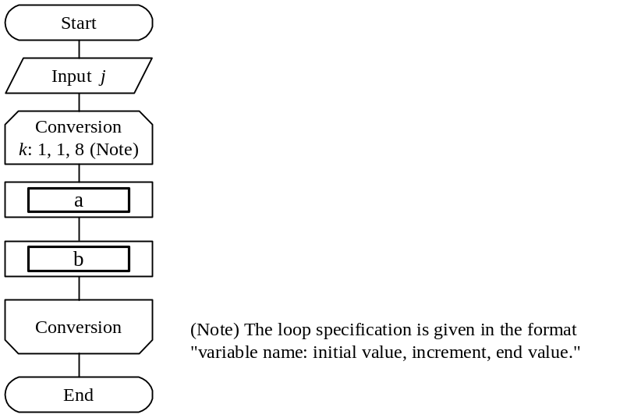

 | a | b
a) | j div 2 → j | j mod 2 → BIN [k]
b) | j div 2 → BIN [k] | j mod 2 → j
c) | j mod 2 → j | j div 2 → BIN [k]
d) | j mod 2 → BIN [k] | j div 2 → j

Comment: NISHIN (meaning "binary") is used for BIN (short for "binary") in the Japanese version.
Ans: Đáp án D. Trong mỗi vòng lặp, phần tử dư sẽ được đưa vào trong mảng và giá trị của số j sẽ được chia cho 2. VD: j = 3 -> k =1 -> BIN[1] = 1 -> j = 3/2 = 1 -> k = 2 -> BIN[2] = 1 -> j = 1/2 = 0 -> k =2..8 -> BIN[k] = 0; j =0 -> BIN = 11000000 viết ngược lại = 00000011

Q60. "A" and "B" below are both algorithms for determining the value of the function Y = F(X) for X = 0 to 1 in steps of 0.0001. How will "A" compare with "B" in terms of the computation precision and computation time when implemented on a real computer?

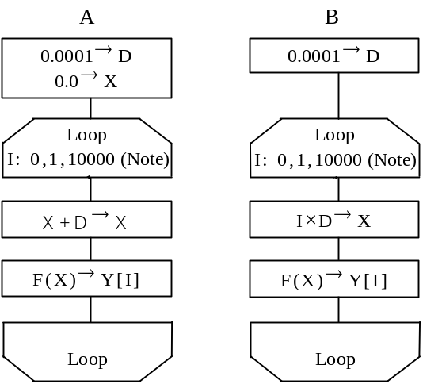
(Note) The loop specification is given in the
format "variable name: initial value,
increment, end value."

 | Computation precision | Computation time
a) | Higher | Longer
b) | Higher | Shorter
c) | Lower | Longer
d) | Lower | Shorter
Ans: Đáp án B. Trong máy tính thì phép cộng sẽ được thực hiện nhanh hơn và chính xác hơn so với phép nhân. Chính vì vậy độ chính xác của thuật toán A sẽ cao hơn thuật toán B, cũng như thời gian của nó nhanh hơn so với thuật toán B.

Q61. If the system development process is divided into definition of requirements, high-level design, low-level design, program design, and programming, which of the following tests is used primarily for verification of the high-level design?

a) Operations test b) Integration test
c) System test d) Unit test

Comments: “High-level design” and “low-level design” are often called “external design,” “internal design” respectively in Japan.
Ans: Đáp án C. Với mô hình chữ V, ta có D tương ứng với phần Programing. B tương ứng với phần Program Design và Low-Level Design. A tương ứng với phần Requirements.
Q62. Which of the following is a suitable testcase to test the logic shown in the diagram by means of branch coverage test?
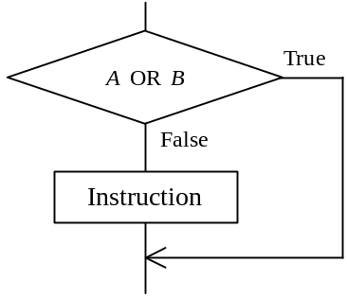

a) b) c) d)
A | B |  | A | B |  | A | B |  | A | B
False | True |  | False | True |  | False | False |  | False | True
 |  |  | True | False |  | True | True |  | True | False
 |  |  |  |  |  |  |  |  | True | True
Ans: Đáp án C. A,B,D chỉ cho phép đi qua nhánh True.

Q63. Which of the following is a proper description of a special feature of the function point method, a method that is used to estimate workload required for software development?

a) The function point method identifies the products to be developed and the tasks to be performed for them, and estimates the workload for each product according to a certain criteria.
b) The function point method is difficult to apply if no similar system has been developed in the past.
c) The function point method uses standard values for counting the lines of code (LOC) and converting them to workload, making it comparatively easy to calculate the required development workload.
d) The function point method is easy for users to understand because it uses as the unit of estimation the count of the screens and reports that users can see.
Ans: Đáp án D. Câu A là nói về phương pháp dựa trên nhiệm vụ chuẩn. Câu B là yếu tố chung vì nếu có hệ thống tương tự được phát triển trong quá khứ sẽ dễ ước lượng hơn. Câu C là nói về phương pháp ước lượng LOC.

Q64. Based on the information shown below, what is the cost of production of the product, in millions of yen?

Unit: 1 million Yen
Indirect production cost | 60 | Direct costs | 100 | Direct labor costs | 120
Direct material cost | 200 | Marketing costs | 90 | General administrative costs | 30
Product selling price | 900

a) 360 b) 420 c) 480 d) 510
Comment: ‘yen’ is the Japanese currency. It should be replaced by US currency or the currency used in your country.

Ans: Đáp án C. Chi phí sản xuất = 60 + 100 + 120 + 200 = 480. Chi phí marketing + adminstrative = Chi phí quản lý (không phải là chi phí sản xuất)

Q65. A certain product has been experiencing gradual increases in its purchase price. There was inventory of this product remaining at the end of the previous quarter, and there has been several inventory turns in the current quarter. When evaluating the inventory on hand at the end of the current quarter, which method of evaluation will generally yield the highest appraised value?

a) Last in, first out method b) Moving average method
c) First in, first out method d) Total average method
Ans: Đáp án A. Để giữ giá hàng hóa trong kho cao thì với giá hàng hóa tăng so với kì trước thì ta sẽ thay thế hàng hóa cũ có giá thấp hơn với hàng hóa mới có giá cao hơn. Ở đây ta sử dụng phương pháp vào trước, ra trước.

Q66. Which of the following is the best description of EOS(Electronic Ordering System)?

a) EOS is a system based on EDI, makes standard agreements concerning transactions between enterprises, and support processing for procurement to manufacturing, shipping, consumption, and disposal.
b) EOS is a system for accepting customer orders over the Internet.
c) EOS is a computer system for retailers that collects and manages information in real-time as products are sold so that stores can know how many of which products were sold when.
d) EOS is an online ordering system that is designed to improve the accuracy and efficiency of ordering operations.
Ans: Đáp án C. EOS là hệ thống đặt đơn điện tử cho phép tự động đặt đơn dựa trên thông tin thời gian thực của hàng hóa và kho hàng để tự động đặt hàng.

Q67. Which of the following is a suitable example of the application of ABC analysis?

a) Divide a region into three areas according to a certain objective, select an opinion leader in each area, and conduct repeated surveys in order to learn about trends and conditions in each area.
b) Sort separate products in descending order of their selling prices or gross profits, divide the cumulative ratios into three ranks, and conduct a product analysis in order to learn which products sell well.
c) After dividing a region into a grid along longitudinal and latitudinal lines, collect data on population, purchasing power, etc., for each cell in the grid, and perform an even more precise regional analysis.
d) Based on sales data from receipts, analyze the combinations of products purchased by customers, etc.
Ans: Đáp án A. Chia thành 3 phần, chọn lựa cách sử dụng với mỗi phần này theo thứ tự dựa vào mức độ ưu tiên của mỗi vùng.

Q68. Which type of bar graph has specific interval widths and boundary values between intervals, and expresses the distribution of the counts of the measured data elements?

a) Scatter diagram b) Cause and effect diagram (fish bone diagram)
c) Pareto diagram d) Histogram
Ans: Đáp án D.

Q69. Which of the following statements about correlation coefficients is true?

a) When there is complete positive correlation, the correlation coefficient is "+1."
b) When there is a linear relationship in the amount of change, the correlation coefficient is "0."
c) When there is a nonlinear relationship in the amount of change, the correlation coefficient is always negative.
d) When there is no correlation, the correlation coefficient is "-1."
Ans: Đáp án A. Hệ số tương quan được xác định mối quan hệ tương quan giữa 2 yếu tố. B sai vì còn phụ thuộc . D sai vì không phụ thuộc thì giá trị của nó sẽ là 0. C sai vì nó không phụ thuộc tuyến tính hay không tuyến tính. B sai vì có thể âm tùy thuộc vào tương quan âm hay dương.

Q70. When four people are picked at random, what is the probability that at least two of the people will have been born in the same month? Assume that the probability of birth is equal for the all months.

a) 0.25 b) 0.43 c) 0.57 d) 0.62
Ans: Đáp án B. Số lượng các tháng là 12. Xác suất để ít nhất 2 người cùng tháng = 1 – xác suất 4 người đều khác tháng = 1 – (Số lựa chọn 4 người 4 tháng khác nhau) / (Số lựa chọn tùy ý cho 4 người) = 1 - 12 * 11 * 10 * 9 / 12 * 12 * 12 * 12 = 0.427.. ~ 0.43

Q71. Which of the following statements about standard deviation is true?

a) The standard deviation of all data plus constant "a" is equal to the original standard deviation plus constant "a)"
b) The standard deviation of all data plus constant "a" is equal to the original standard deviation multiplied by "a)"
c) The standard deviation of all data multiplied by two is equal to the original standard deviation divided by two.
d) The standard deviation of all data multiplied by two is equal to the original standard deviation multiplied by two.
Ans: Đáp án D.

Q72. Which of the following descriptions of Shift JIS Code is correct?

a) Shift JIS Code consists of 8-bit codes and can be used to represent 256 characters.
b) Shift JIS Code is a code system that was adopted as the BMP (Basic Multilingual Plane) in ISO/IEC 10646, and was created for the purpose of facilitating data exchanges between personal computers.
c) Shift JIS Code is a standard for kanji codes specified in JIS X 0208, and consists of two-byte codes that are used to represent single characters. Each byte has a value ranging "21" and "7E" (hexadecimal). The codes are divided into Level 1 and Level 2 according to their frequency of usage.
- Shift JIS Code is a conversion of the JIS kanji code system that can identify one-byte alphanumeric and kana codes intermixed with two-byte kanji codes.

Comment: This question is not applicable to countries other than Japan. Therefore, it is recommended to delete this or replace this by an appropriate question concerning information interchange code in your country or by a question on unicode which is an ISO standard to allow the use of two bytes for each characters so that character sets in different (non-western) countries can be represented.

Ans: Đáp án C. Shift JIS Code là một biến đổi từ hệ mã JIS và nó chứa 16 ký tự. D sai do gồm 24 kí tự. A sai cũng như vậy. B sai do nó không biến đổi từ hệ mã JIS.
Q73. Which of the following charts or diagrams is used to express work schedules and execution?

a) SD chart b) Venn diagram
c) Gantt chart d) Decision tree
Ans: Đáp án C. Biểu đồ so sánh lịch và công việc thực tế là biểu đồ Grantt.

Q74. Which of the following statements concerning system audits as stipulated in "System Audit Standards" is true?

a) A system auditor conducts a comprehensive inspection and evaluation of an information system from an independent and objective standpoint, and then reports the results to the head of the organization.
b) A system auditor conducts tests to determine whether processing is performed as planned, and authorizes release of the system.
c) A system auditor evaluates the performance of a system and reports the results to the users of the system.
d) After comprehensive testing of the information system is completed, a system auditor evaluates the system from the aspect of security, such as functions designed to prevent illegal access, and then endorses its transfer to the user.
Ans: Đáp án A. Kiểm toán hệ thống đứng ở một góc nhìn độc lập và thông báo kết quả tới người đứng đầu tổ chức.

Q75. Which of the following statements concerning measures to protect against computer viruses is true?

a) A disk infected with a virus should be reformatted logically in order to delete the virus from each infected file.
b) When installing software from rewritable media, the software should be installed without using any write-protection measures.
c) Before installing software, you should first confirm that the computer itself has not been infected with a virus.
d) Because anti-virus measures are the responsibility of the individual even in a multi-user system, there is no need to designate someone to be responsible for anti-virus measures.
Ans: Đáp án A. Một đĩa nhiễm virus nên được format lại để xóa hết virus trong file. B,C sai vì software đó có khả năng nhiễm virus. D sai vì điều đó sẽ làm nhiễm virus dễ hơn.

Q76. In a method that verifies users by comparing their input password with their registered password, which of the following is a measure to prevent the theft of registered passwords by illegally accessing the password file?

a) Register the hash value of the user ID corresponding to each password, then use the hash function to convert the user ID that is input during verification and compare the registered password with the input password.
b) Register the password as is, then use the hash function to convert both the password that was input for verification and the registered password, and then compare the results.
c) Register the password as is, and compare that password with the password that was input for verification.
d) Convert the password to a hash value and then register the hash value; when a password is input for verification, convert that password to a hash value with the hash function and then compare the hash values.
Ans: Đáp án D. Ta sẽ lưu hash value của password, khi người dùng nhập password, ta sẽ hash giá trị đó và so sánh với giá trị đó với giá trị hash được lưu.

Q77. Assuming the number of characters in the character set that is used for a password as "M" and the number of characters in a password as "n," which formula derives the number of passwords "P" that can be set?
a) | P = M ^{n} | b) | P = | M!
 |  |  |  | (M–n)!

c) | P = { | M! | }× | 1 |  | d) | P ={ | (M+n–1)! | }× | 1
c) | P = { | (M–n)! | }× | n! |  | d) | P ={ | (M–1)! | }× | n!

Ans: Đáp án A. Số kí tự là n. Số khả năng là M. Vậy số khả năng sẽ là M^{n}

Q78. Which of the following statements concerning copyrights is true?

a) All the phases of development, from analysis to production, of Company M's business program were undertaken by Company N. The original copyright holder of this program is Company M.
b) Even just using the idea of an existing program to produce an entirely new program for the same purpose is an infringement of the copyright on the existing program.
c) Copyrights and author personal rights can be transferred to another person.
- In Japan, duplication and distribution of copyrighted material without permission is an infringement of copyright, even if the copyright symbol is not clearly indicated on the copyrighted material.
Comment: Statement D should be changed to reflect the law or regulation in your country.
Ans: Đáp án C. B sai vì nếu dùng một phần của chương trình cũ để sản xuất một chương trình mới có nội dung tương tự không vi phạm bản quyền nếu được thỏa thuận của tác giả. A sai vì tùy vào thỏa thuận giữa 2 công ty. D sai vì phải đăng ký theo luật bản quyền.

Q79. Which of the following statements concerning a comparison of patents and copyrights is true?

a) In the case of patents, an original invention can still infringe on another party's rights if that party acquired those rights earlier, while in the case of copyrights, an original work cannot infringe on another party's rights, even if the result of that work is identical to the existing work.
b) Patents protect ideas that are new or progressive and that use natural laws, while copyrights protect programming languages and protocols that contain creative elements.
c) A patent right is secured when a patent is submitted to Japan’s Patent Office, checked and registered, but a copyright to a program is secured only when the program is registered with the registration agency specified by the Director General of the Agency for Cultural Affairs.
- The objective of patent laws and copyright laws is to contribute to the advancement of industry by protecting rights.
Comment: Statement C should be changed to reflect the way how patent rights accrue in your country.
Ans: ????

Q80. In which of the following types of employment arrangements does the worker not conclude an employment contract with the company at which he works?

a) Non-regular employee b) Part-timer
c) Loan employee d) Temporary employee
Comment: The classification of the above employees may not be applicable to your country.
Ans: Đáp án B.

